1. How to submit the application?
After logging into the system https://jsos.pwr.edu.pl/, a graduate student with ‘Active’ or ‘On leave’ status will have the Diploma tab available (Fig. 1)

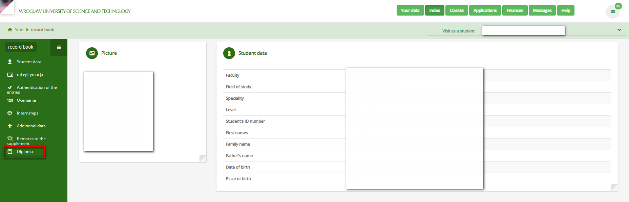Rys. 1

After clicking on the Diploma tab, an Application for a complete set of diploma documents will appear with options to be completed by the student (Fig. 2).

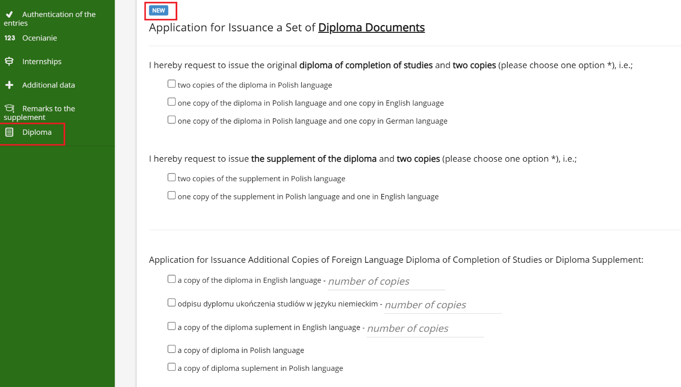
Rys. 2
In the application, please use the checkbox to check the appropriate fields and indicate your choice (Fig. 2). Please note that you must select one of the options for the Diploma of Completion of Studies and one for Diploma Supplement. Additionally, you may order additional copies of the Diploma and Supplement and enter the appropriate quantity in the ‘number of copies’ field.
Before choosing the option, you can get acquainted with the fees (Fig. 3).

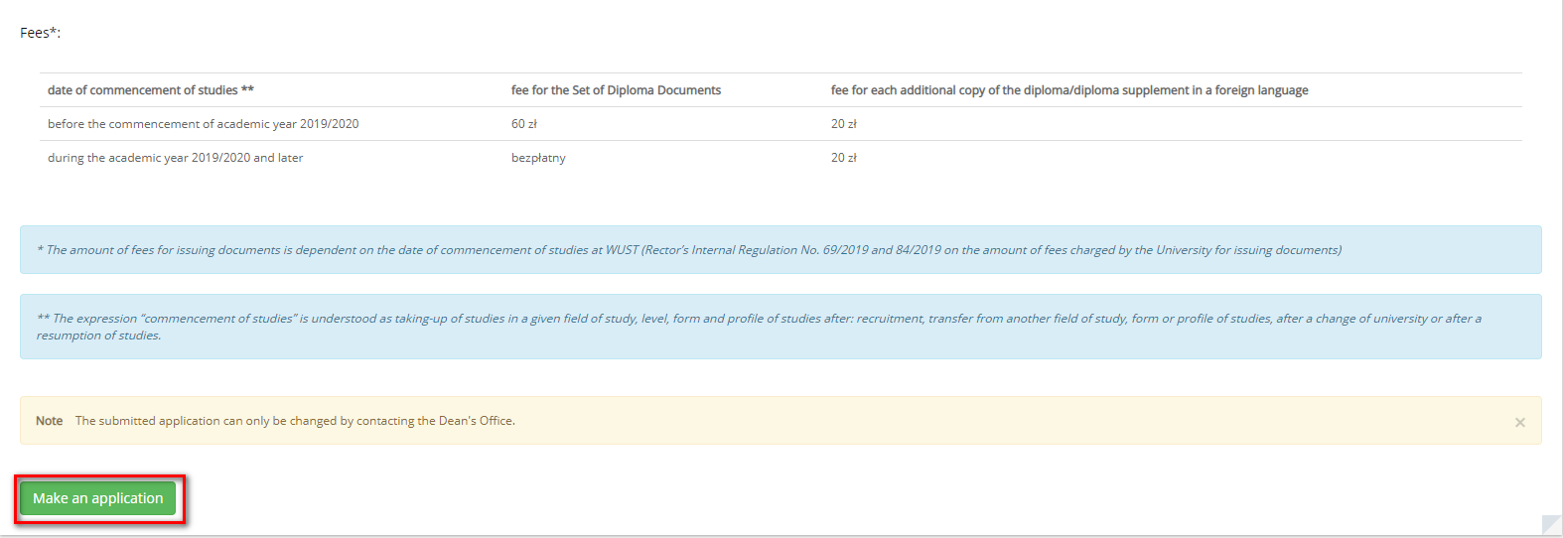
Rys. 3

After selecting the appropriate options, you can send the application to the Dean's Office with the button, (Fig. 3).

Before the final submission of the application, there is a message saying (fig. 4):

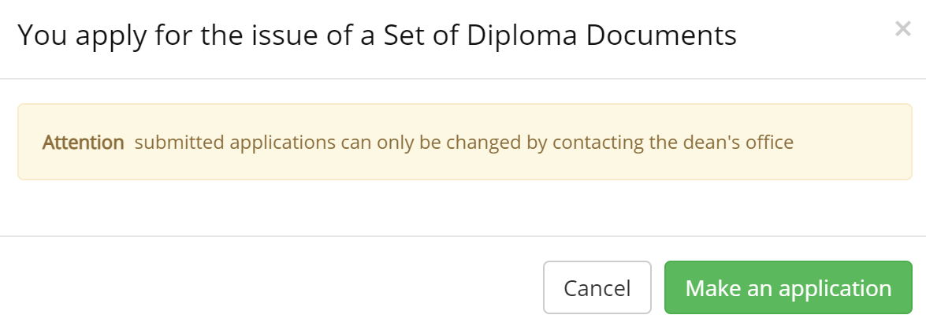
Rys. 4
After sending the application, it is not possible to edit it in JSOS. The application may be edited only by contacting the Dean's Office.

After sending the application to the Dean's Office, the application receives the status (Fig. 5).

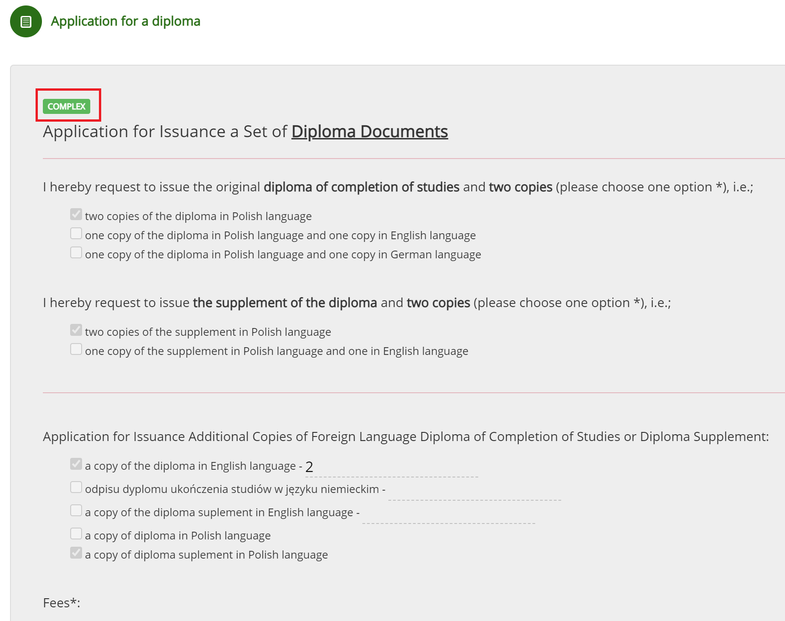
Rys.5
You can print / preview the application. The button serves this purpose (Fig. 5).

